CAPABILITIES GUIDE

LET US HELP YOU PROTECT WHAT YOU BUILD WITH PIPESAK FILLING SERVICES

SAVE TIME.
PipeSak offers professional filling services to meet any construc- tion schedule. With experienced crews we can provide filled geotextile pipeline weights for any number of spreads, in multiple locations, 24/7. PipeSak professional crews can often fill twice the number of weights using the same equipment and labour as inexperienced crews or third-party contractors, saving you time. We also provide a ROW representative to inspect and train your stringing crew on proper han- dling and installation procedures, making sure every weight is installed quickly and easily.

SAVE MONEY.
Cost savings are important to our customers, and important to us. PipeSak has warehouses across North America, strong relationships with our aggregate, equipment and freight providers, and experienced filling crews that help us offer our customers the most competitive filling rates
- through out North America. Take the financial risk out of your projects and let PipeSak provide you with a finished filled geotextile pipeline weight, ready for installation.

GUARANTEED QUALITY.
When you choose PipeSak to provide your filling services you get guaranteed quality and service. PipeSak carefully selects the appropri- ate aggregate to suit your climate and buoyancy design requirements. We adhere to strict quality assurance guidelines to ensure all of our filled pipeline weights meet your project specifications. We weigh each and every bag and provide our customers with daily filling reports to keep you up to date on our progress. We stand behind our products and will do whatever it takes to keep our customers satisfied. Our crews are ISN registered and in full compliance. Take the risk out of filling your weights and let PipeSak take care of it.

PIPESAK FILLING PARTNERS – ANYWHERE, ANY QUANTITY
Sometimes you only need a few weights. Sometimes you need them yesterday. PipeSak has partnered with local filling companies to sup- ply our customers with competitively priced, filled geotextile pipeline weights, often next day. PipeSak filling partners stock filled weights and can offer trucking direct to your project. They can also deploy filling crews to fill, either in your yard or close to the ROW.

INDIGENOUS PEOPLES INVOLVEMENT
PipeSak Filling Services has partnered with Native American tribes in the US and First Nation and Metis bands in Canada to provide our customers with the option to include aboriginal content in their pipeline weighting. From sourcing aggregate, to trucking, to labour and equip- ment, PipeSak has successfully supplied large pipeline projects with our aboriginal partners for over 20 years.

CONTACT INFORMATION:
2800 Post Oak Blvd., Houston, TX 77056 Tel: 1-866-PIPESAK
Email: info@pipesak.com Website: www. pipesak.com
FAST. SIMPLE.
COST EFFECTIVE.
GUARANTEED.

PROFESSIONAL FILLING SERVICES
PipeSak® deploys multiple crews to fill and stockpile any quantity of weights required to meet your construction schedule. Strict quality control ensures a properly filled, accurately weighed PipeSak® using our specially designed Quick-Fill and release system. GUARANTEED!
PipeSak® Quick-Fill
STRONG
ECO-FRIENDLY
PipeSak® Original

SAFE & DURABLE
EASY INSTALL

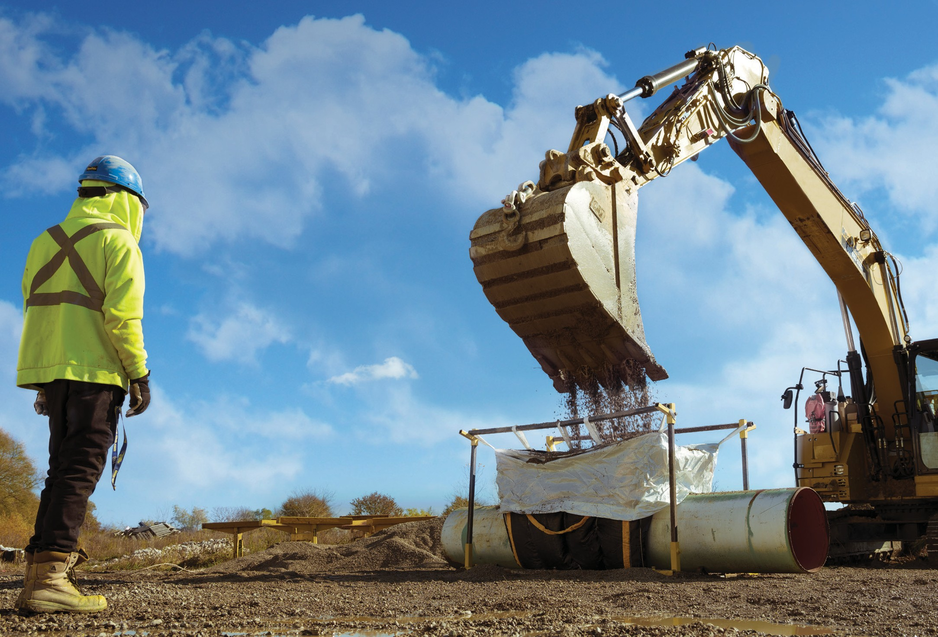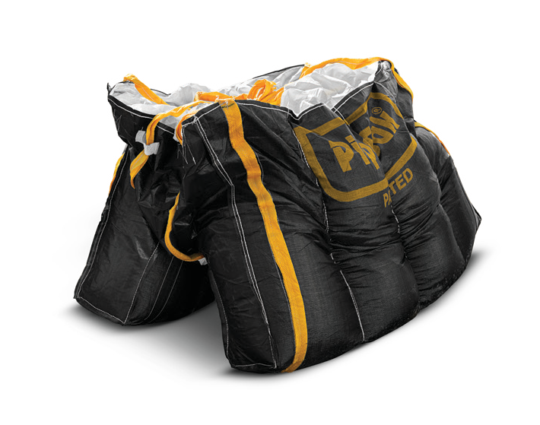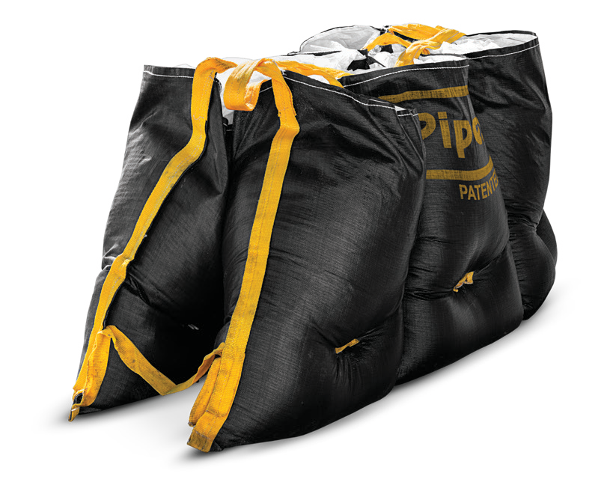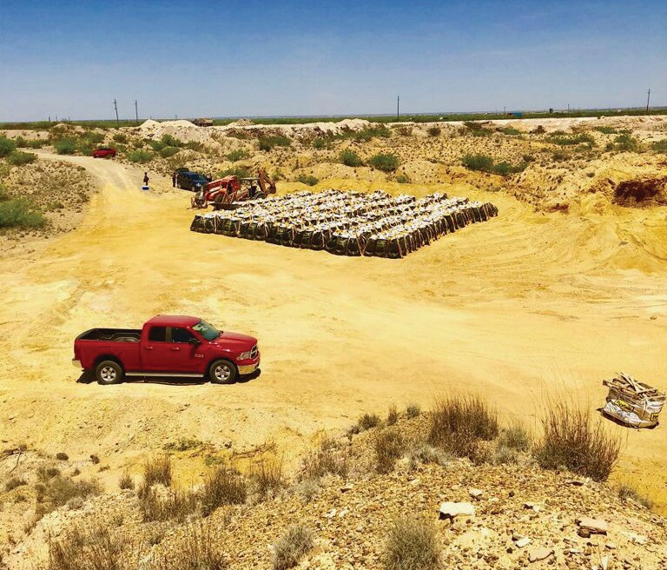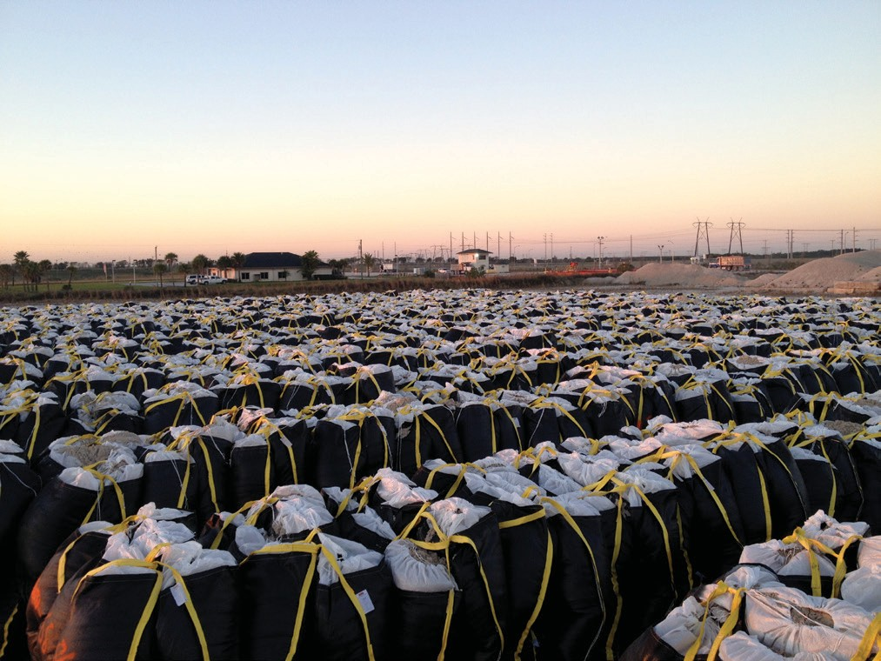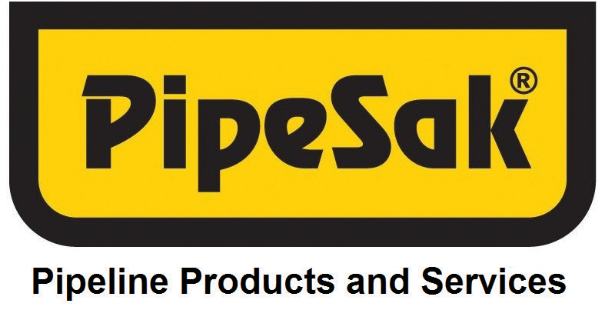

T | Pipeline & Gas Journal • July 2018 SPONSORED CONTENT
PIPESAK.COM
+1 866.PIPESAK (747.3725)
ENGINEERED PIPELINE SOLUTIONS
WE PROTECT WHAT YOU BUILD.

